STATEMENT OF WORK 2025-20
“TeleLife Conversational AI Proof of Concept”

This Statement of Work (“SOW”) is made and entered into as of December 2, 2026 (“SOW Effective Date”) by and between Capgemini America, Inc. (“Capgemini”) and Protective Life Insurance Company (“Client” or “Protective”). By signing below, the parties agree to the terms and conditions of this SOW, which shall be governed by the Master Services Agreement entered into by the parties dated March 19, 2021, as amended (“Agreement”). The terms and conditions of the Agreement are an integral part of this SOW and are hereby incorporated herein. Capitalized terms not defined herein shall have the definitions given to them in the Agreement.

- Project Description
Protective Life intends to explore conversational voice automation possibilities. Part of this exploration is to test how AI can improve its TeleLife interview process by developing an AI agent capable of conducting phone interviews with prospective customers. During an 8-week a Proof of Concept (“POC”), Capgemini will build and evaluate a conversational voice agent that follows a pre-defined part of the TeleLife questionnaire, records responses in real time, manages deviations from the standard interview flow, and generates completed interview records. The objective is to demonstrate feasibility and present a summary document for leadership consideration.

- Service in Scope
Capgemini shall provide the following services to Client under this SOW (collectively, the “Services”):

- Confirm the part of the TeleLife interview process that will be the scope of the POC.
- Develop a conversational voice agent for applicant interviews using the pre-defined part of the structured questionnaire.
- Showcase live interaction and automated summary collection in a sandbox environment using synthetic data.
  - Out of Scope
- Integration with any Protective IT environments (development, test or production)
- Use of real customer data
- Multi-language support, besides English
- Implementation of future state recommendations
- Any services or obligations not expressly denoted herein as being included in the scope of Services

  - Activities
- Phase 1: Preparation & Design (Weeks 1–2)
  - Obtain and review relevant current-state business, process, and architecture documentation.
  - Conduct Kick Off Meeting.
  - Finalize Proof-of-Concept scope and success metrics.
  - Convert TeleLife questionnaire into structured data format (JSON/Dataverse).
  - Confirm sandbox setup, Azure resource provisioning, and access.
- Phase 2: Build & Integration (Weeks 3–4)
  - Develop core conversation logic and orchestration layer using Azure Functions and Azure OpenAI.
  - Integrate Azure Communication Services for PSTN connectivity.
  - Implement branching logic and session state management.
  - Configure RAG service for grounding responses in TeleLife questionnaire.
  - Validate security setup using Azure Key Vault.
  - Conduct interviews with stakeholders focusing on aspects related to future AI scaling.
- Phase 3: Testing & Refinement (Weeks 5–6)
  - Conduct initial internal testing of the voice pipeline and logic flow.
  - Perform dry-run tests with synthetic data to validate accuracy and latency.
  - Refine prompts, error handling, and escalation triggers.
  - Gather internal feedback and make iteration adjustments.
  - Validate data output structure and summary generation.
  - Conduct two small focus group workshops with business stakeholders one with technical stakeholders.
- Phase 4: Demo (Weeks 7–8)
- Conduct client-facing demo showcasing end-to-end call handling.

  - Project Plan

The high-level project plan and timeline is below. Any changes shall be subject to the change control procedures.

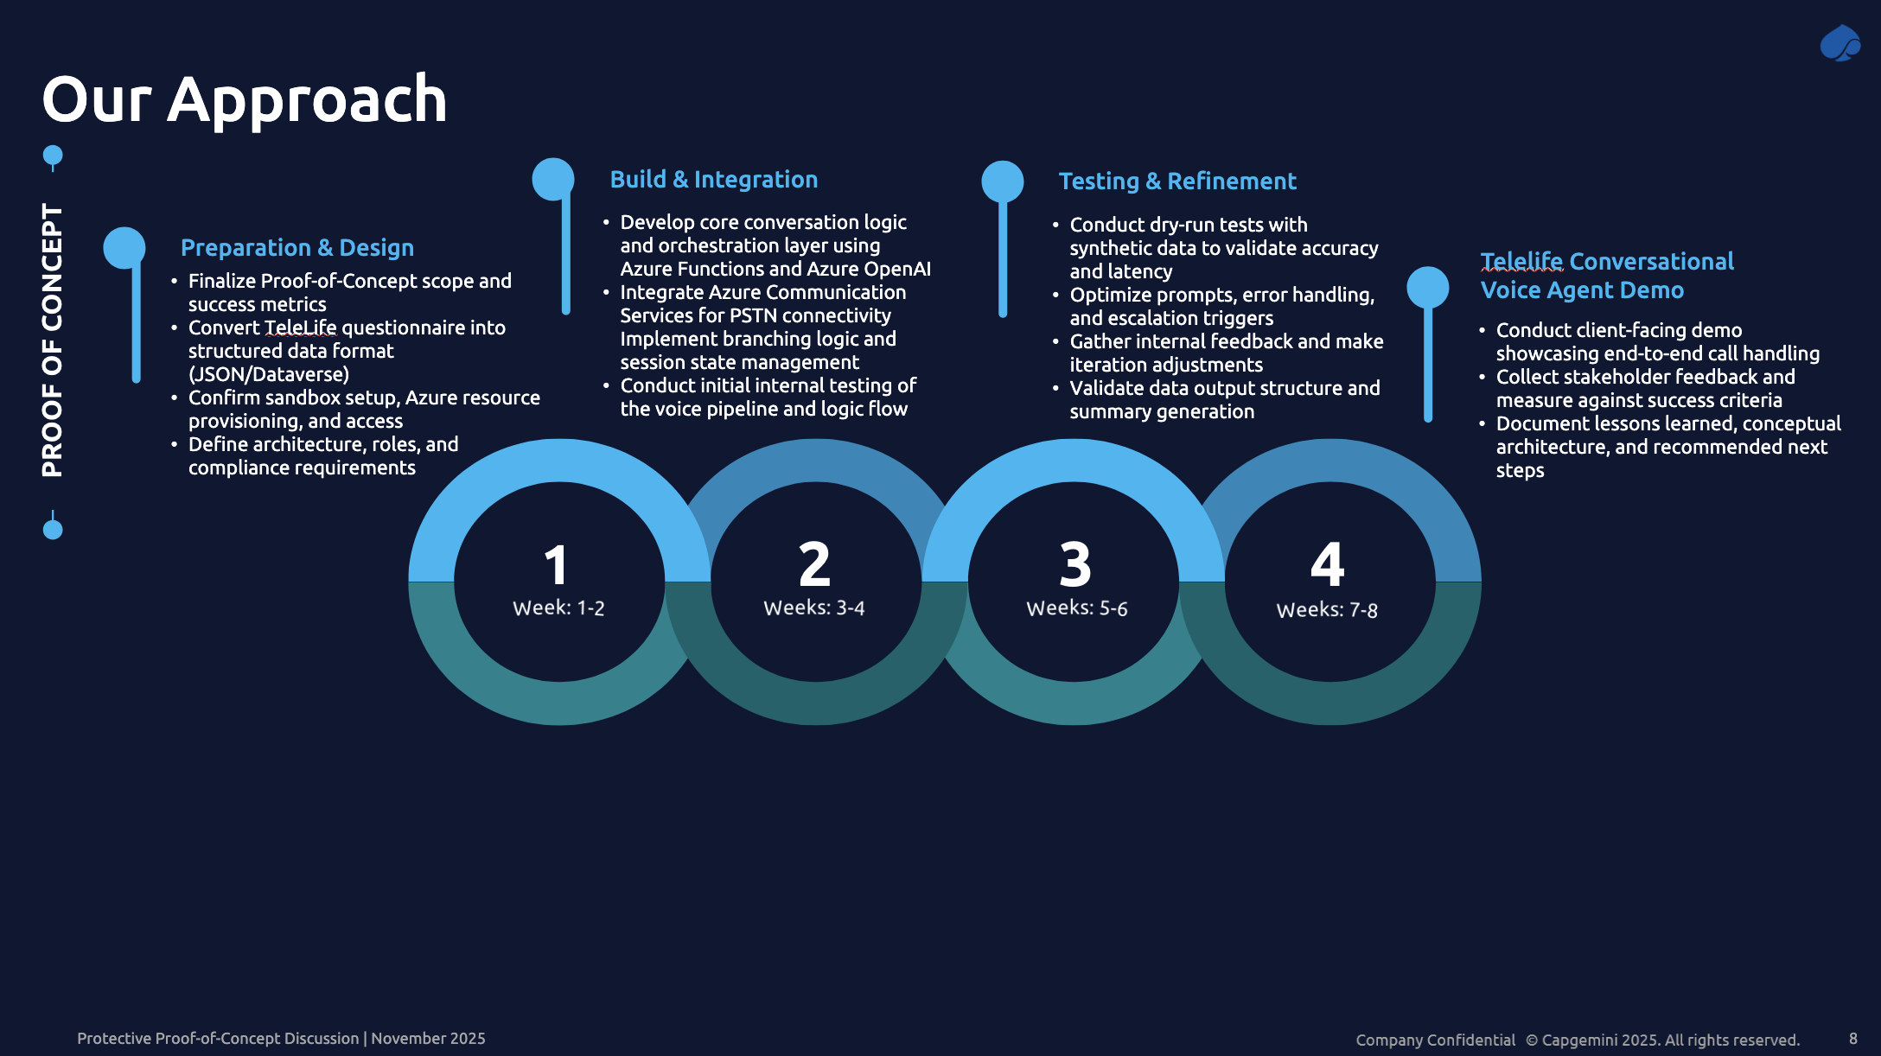

  - Deliverables
Ref | Deliverable | Purpose and Format | Acceptance Criteria | Client Dependency | Est. Delivery
D01 | Kick-off Meeting Presentation | Provides plan and approach for the engagement in Microsoft PowerPoint | Presentation that lays out the approach, process and timeline. | Client to provide list of stakeholders to be included kick-off meeting. | Week 4
D02 | TeleLife Conversational Voice Agent | Demonstration in sandbox environment covering up to 20 questions of the TeleLife questionnaire | Functionality of TeleLife Conversational Voice Agent demonstrated (according to success criteria jointly defined and decided with Protective Life) | Provide TeleLife questionnaire, aligned success criteria, stakeholder availability | Week 11

Acceptance of Deliverables:
Client shall notify Capgemini in writing within three (3) business days of delivery (“Acceptance Period”) if a Deliverable fails in any material respect to meet agreed upon specifications or other Acceptance Criteria; Capgemini shall make such revisions as necessary to cause such Deliverable to meet the specifications and/or other Acceptance Criteria and re-submit such Deliverable to Client. Capgemini will have the right to rely upon Client’s acceptance of a Deliverable as the basis for subsequent work on the engagement. A Deliverable will be deemed accepted if not rejected within the Acceptance Period.

- Term of the SOW
The Term of this SOW shall commence on December 15, 2025, and shall expire eleven (11) weeks thereafter. Either Client or Capgemini may terminate this SOW for its convenience upon thirty (30) days’ prior written notice to the other party. In the event of any termination for convenience of this SOW by Client, Client shall pay Capgemini for all fees and expenses incurred through the effective date of termination based on actual work performed.

- Location of Performance of Services
Capgemini will perform the Services from Capgemini’s offices in the US, Capgemini’s local offices and offshore affiliate’s offices in India, as well as Capgemini personnel India and US home locations.

- Fees, Expenses, Invoicing and Payment Terms
Capgemini’s fees for Services provided under this SOW will be billed on a fixed-price basis, as set forth below, exclusive of expenses. Client will be invoiced by Capgemini in accordance with the schedule below. Client shall pay Capgemini’s invoices within thirty (30) days following receipt of the invoice.

Invoice Schedule | Due Date | Amount
TeleLife Conversational Agent POC |  | $221,334
One-Time Partnership Discount |  | -$141,334
TOTAL FIXED FEE | 12/15/2025 | $80,000

Any delay in the completion of any applicable invoicing milestone that is attributable to a failure or delay by the Client will not impact the invoicing or payment related to such milestone. Thus, for example, if a milestone is delayed due to a failure or delay by the Client (such as a failure by the Client or its vendors or contractors, or other parties, to perform their obligations in connection with the project; the failure of software or hardware to perform as expected; or the failure of any of the assumptions established in this SOW), then the applicable milestone-based fee shall be invoiced and become payable on the originally projected completion date for the milestone. Any affected milestone date shall be extended according to the change control procedures of the Agreement.
In the event of termination of this SOW for any reason, Client shall pay Capgemini, on a pro-rata basis, for all Services rendered, Deliverables delivered, and expenses incurred, through the date of termination, whether or not such payments are otherwise then due and payable.
Capgemini will also invoice Client for necessary out-of-pocket expenses incurred by Capgemini and its personnel in the course of providing the Services. Such expenses may include, but are not limited to, travel, accommodations, meals and local transportation costs incurred when traveling on behalf of Client for on-site work efforts or otherwise. All out-of-pocket expenses must be pre-approved by Protective in writing prior to being incurred.

- Responsibilities
Each party shall perform its respected tasks and responsibilities stated herein. Capgemini will perform the Services in accordance with all requirements of the Agreement and this SOW. Each party acknowledges that project duration and cost under this SOW may be affected if a party fails to promptly and completely perform its tasks and responsibilities on time. In such event, the parties will negotiate necessary variations to this SOW in good faith to address necessary changes.

- Client will provide a project sponsor or manager (“Client Project Director”) for all communications with Capgemini, with the authority to act for Client. The Client Project Director will have the following responsibilities:
- Serve as the single authorized point of contact between Capgemini and Client;
- Identify, schedule and confirm the availability of Client SMEs for meetings and support;
- Work with Capgemini to administer the project change process, if applicable;
- Obtain and promptly provide information, data, decisions and approvals, within five (5) business days of Capgemini request unless both parties agree to an extended response time;
- Resolve deviations from project plans; and,
- Resolve project issues, escalate issues within the Client organization, and monitor and report project status on a regular basis to the pertinent person.
- Client will provide Capgemini with necessary and prompt access to, and ensure the availability of, all personnel, documentation, information, standards, systems and other resources that are necessary for Capgemini to perform and meet its obligations hereunder provided said access and availability does not violate any third-party agreements.
- Client will work with Capgemini to control and manage scope, schedules, resources, and follow project change control processes as required.
- The parties acknowledge that it is not expected that the Client will disclose any personal data hereunder, absent prior agreement of the parties.
- All Client data accessed by Capgemini in providing the Services under this SOW must remain in the Client designated environment, and Capgemini is not permitted to remove any such information from the Customer designated environment. Client will not provide Capgemini with such Client Data outside Client designated environment.
- Once the parties agree to which software and other material will be needed by Capgemini, Client will confirm that it possesses the necessary license rights to allow Capgemini personnel to legally use all software and other materials provided by Client to Capgemini. If further consents required from any third party(ies), Client shall obtain such consent(s).
- Client will be responsible for providing the VDIs used in performance of the Services. Additional software requirements necessary for the completion of the Services may be identified in the Project Plan delivered to Client, subject to Client’s prior written approval. After confirmation of the requirements with Client, Client will provide to Capgemini the additional software within a reasonable time, including the right for Capgemini to use the software required to complete the Services.
- Client agrees to provide supporting documentation confirming this SOW and the Services performed by assigned Capgemini personnel to submit to appropriate immigration authorities for immigration purposes for Capgemini’s employees.

Assumptions: Capgemini has relied on the assumptions stated below in pricing, planning, and determining its approach to the Services. Client acknowledges that project duration and cost to Client under this SOW may be adversely affected if any project assumptions are changed or not realized, or if there are any additional elements or assumptions.
- The Services do not include creation of user documentation, such as user manuals.
- Environment will run on Capgemini-provided Azure environment with licenses for OpenAI, Speech, Communication Services, and Copilot Studio. The environment will not have any integration with Protective’s IT landscape.
- Development and testing will be done in the Capgemini-provided sandbox environment.
- The scope of the POC shall encompass up to twenty (20) pre-selected questions from the TeleLife questionnaire provided by Protective. The questions to be included within the scope of the POC shall be mutually agreed upon by Protective and Capgemini prior to the start of development activities.
- Client will only provide access to masked or anonymized personal or sensitive data. Client shall not provide Capgemini with access to any PII/PHI data.
- Development and testing will be done using synthetic data only.
- Capgemini will notify Client of any Client or third-party software it deems necessary for the performance of the Services. Subject to Client’s written agreement, Client will provide Capgemini with legal access to, at Client’s sole expense, all Client and third-party software necessary to the performance of the Services. If any other third-party product is needed for the Services, it will be procured and licensed by Client as pre-approved and agreed in writing. Capgemini is not responsible for interface updates or upgrades related to future releases of any Client or third-party software, and any such work is subject to the mutual written agreement of the parties.
- Any changes in scope, budget, or resources must be agreed to between the parties in writing in a change order.
- Both parties will perform its tasks and responsibilities under this SOW in a prompt manner, specifically including all stated Responsibilities.
- Capgemini shall have no obligation to independently verify the accuracy or completeness of the information provided by Client or its agents. Capgemini’s services are informational and advisory in nature, and Client has full responsibility for the use of, and the results obtained from, the services and any deliverables. Capgemini is not providing Client with any legal or financial advice.
- Personnel supplied by either party will not for any purpose be considered employees or agents of the other party. Except as may otherwise be provided in this Agreement, each party shall be solely responsible for the supervision, daily direction and control of its employees and payment of their salaries (including withholding of appropriate payroll taxes), workers’ compensation, disability and other benefits.
- Client’s identified stakeholders will be available for interviews, workshops, and reviews as is necessary. Capgemini will notify Client when such availability is needed.
- All required client stakeholders have been briefed and understand the project objectives as well as their time commitments for active participation and collaboration to this project’s successful delivery.
- Capgemini US-based consultants will perform work from remote locations and travel to Client US-based office location(s) based on the written request from Client.
- Implementation of the assessment recommendations are not included in the scope of this SOW.
- The Services are limited to the activities/deliverables specifically identified in this SOW. Any change to scope, timeline, assumptions, dependencies or any other terms or provisions of this SOW shall be subject to the Changes provision in the Agreement.
- The ‘TeleLife Conversational AI Proof of Concept’ and the ‘Proof of Concept Readout’ SOWs are designed to be delivered as a unified engagement. The Client is required to execute both SOWs; neither document may be accepted independently.

IN WITNESS WHEREOF, the Parties have caused this SOW to be executed as of the Effective Date by their duly authorized representatives.

Capgemini America, Inc. | Protective Life Insurance Company
By: ___________________________ | By: ___________________________
Name: ___________________________ | Name: ___________________________
Title: ___________________________ | Title: ___________________________
Date: ____________________________ | Date: ____________________________

